Groepsopdracht
Yellow
Academiejaar: 2025–2026
BD Groep 2

Gert-Jan Bollen   | Levi Smeets   | Remy Brouwers     | Robbe Koreman  

Contents
1. Contents 1
2. Mobile Security introduction 2
2.1. Bypass 3
2.2. Content Provider Injection 4
2.3. Native libraries 6
3. Secure Coding 8
3.1. SQL Injection 9
3.2. Insecure Storage 9
3.3. CORS 10
3.4. Credentials in Version Control 11

Mobile Security introduction

Bypass
When opening the app and pressing the “Enter” button we get the message “It is not yet time…” I searched for this string with jadx and found out the logic that checks if it is 2AM or not:

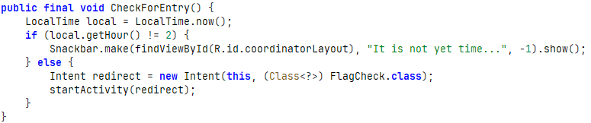
I changed the device time to 2am and pressing enter now brought me to the FlagCheck screen.

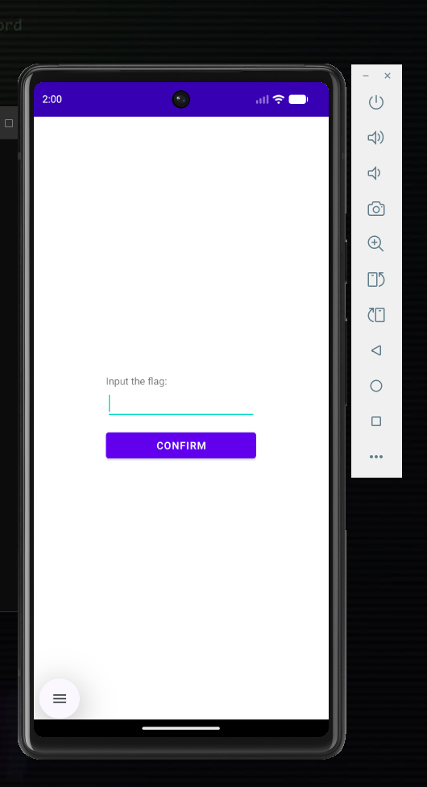

An alternative bypass was to directly launch FlagCheck using android activity manager with:
adb shell am start -n com.example.pxlsecadv/.FlagCheck
Entering a value got us to the same FlagCheck page again.

A third option was to check out the smali code itself, decompiled with apktool, we can find the logic that checks if it is 2am and change it to bypass it and directly launch the FlagCheck page:

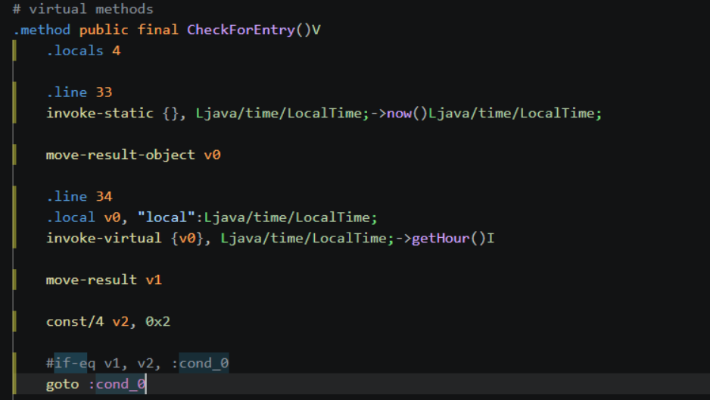

Content Provider Injection
Using apktool, i extracted the android manifest from the provided apk using:
C:\android-tools\apktool\apktool.bat d PXLSecAdv-1706108564503.apk -o pxlsecadv_decoded

Inside the manifest we found an interesting part:

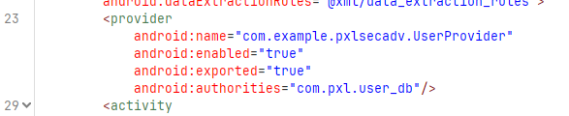

Because the exported content provider with authority com.pxl.user_db has android:exported="true", it can be queried from outside the app.

In JADX, the UserProvider class showed the provider URI as content://com.pxl.user_db/users

Using a content query with that uri returned 3 rows of non admins.
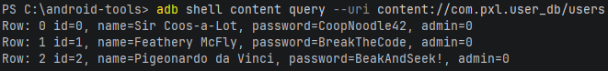
Hunting for admins records I noticed a SQL injection vulnarability in this select:
Using the cmd:

adb shell content query --uri "content://com.pxl.user_db/users/1%20OR%201=1--"

we make it true with OR 1=1 , and -- comments out the last part being AND admin = 0
This returned the database rows, including the hidden/admin record containing the flag

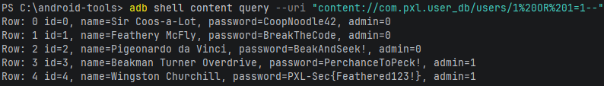

Another way to see the database entries was to checkout the actual database using sqlite:

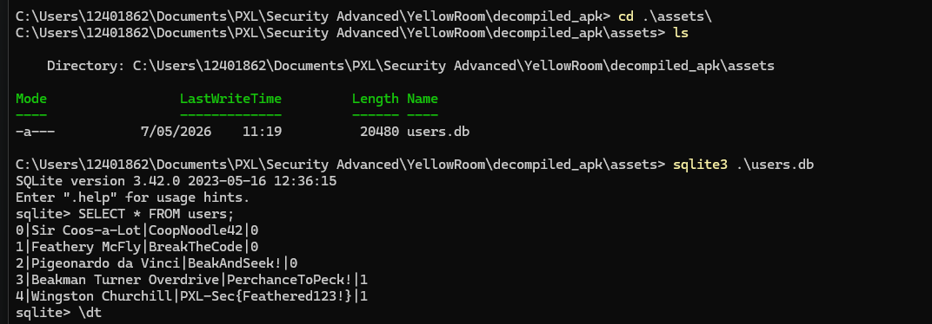
Using these methods we found the flag: PXL-Sec{Feathered123!}

Native libraries
In jadx I found the flagcheck logic
And stringFromJNI seemed to give the flag I need.

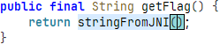

Instead of reversing the native lib named libpxlsecadv.so found in Resources/lib/..
I made a script to hook the method and log the return value.

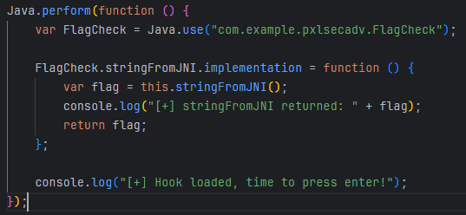

Using frida with cmd: frida -U -f com.example.pxlsecadv -l getflag.js
We get the flag “PXL-Sec{3048Ko3kenD00s}” seen below when pressing the confirm button.

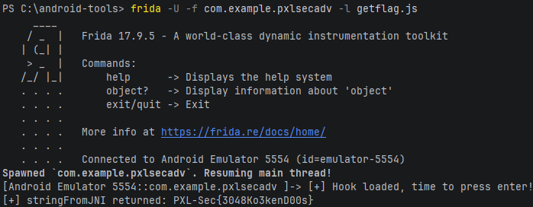

Secure Coding

SQL Injection
By using the standard SQL injection payload ‘OR ‘1’=’1’-- we are able to log in:

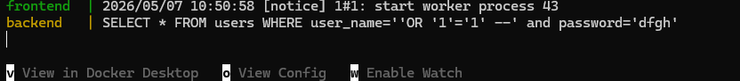
To fix this issue we sanitize the input in index.js:
We use $1 and $2 to catch the user input and pool.query() has builtin checks that give an error when trying to enter malicious login credentials.

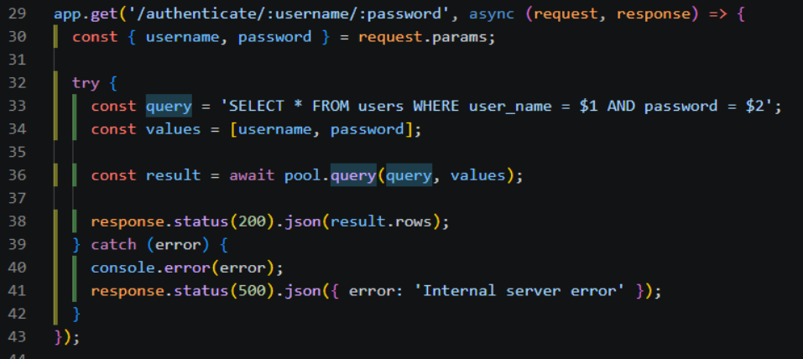
After the modification the SQL Injection doesn’t work anymore:

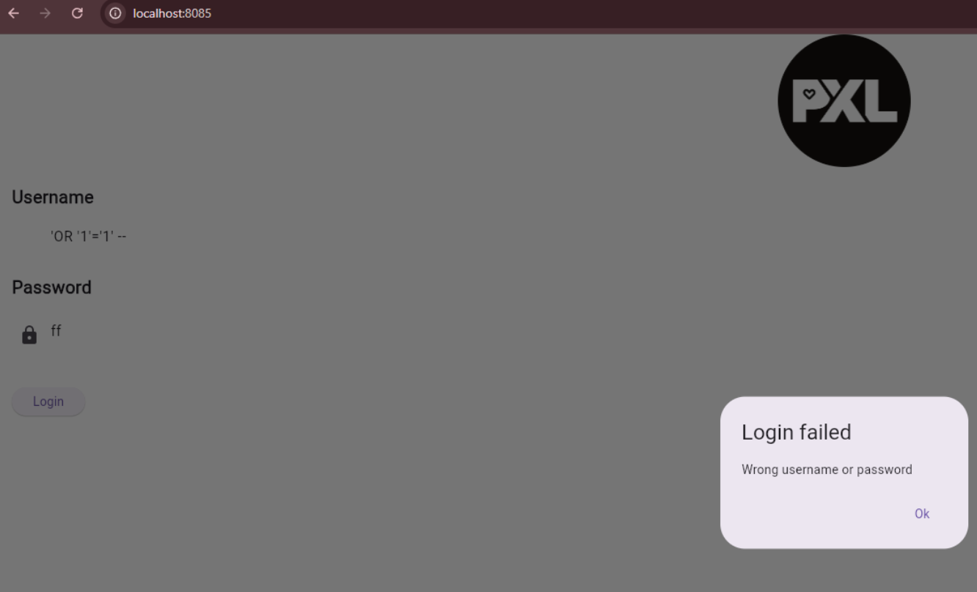

Insecure Storage
To make sure sensitive data is secure, we will use bcrypt. We will again make changes in index.js. We install bcrypt by adding it to the backend package.json and change the login/authentication function so that passwords are encrypted before being stored in the database.

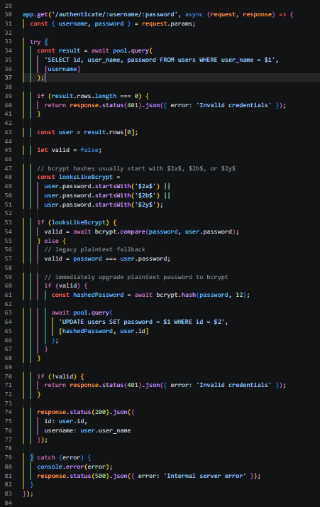

We can see that in the databse when we log in with user George that his password is now secure!
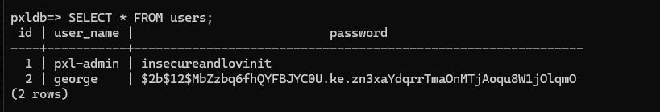

CORS
Without CORS (Cross-Origin Resource Sharing), any website has access to our backend. WIth CORS we are able to explicitly say which website can have access by changing the already existing app.use(cors()); to this:

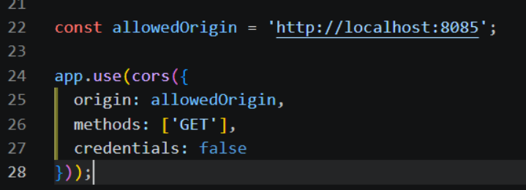

Credentials in Version Control
There are a couple of options to get rid of all the credentials hidden in different files, one of these is using .env files (make sure these are added to your .gitignore!). Another option is using a vault that encrypts the secrets (Hashicorp, ansible vault, ...). If credentials have already been exposed make sure to rotate all of the credentials that were exposed.

In index.js you could use this and then also have a seperate .env file with the needed credentials:

